**SSRS Process:**

The first report shows us the amount of active and inactive customers at any given time based on the start and end parameters of the date we entered in "Shared Datasets" in SQL language.

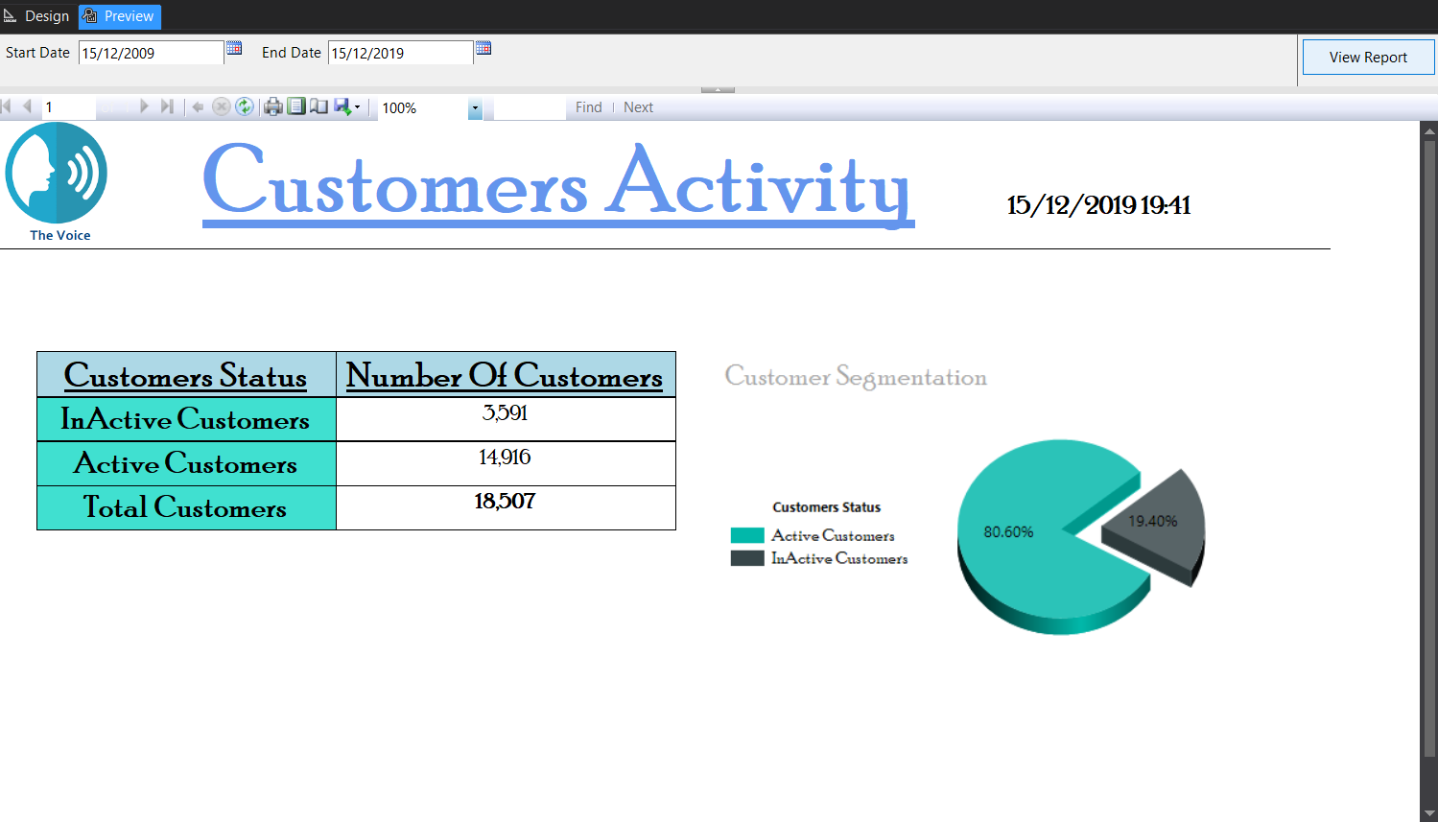During the entire period there were 3,591 inactive customers.

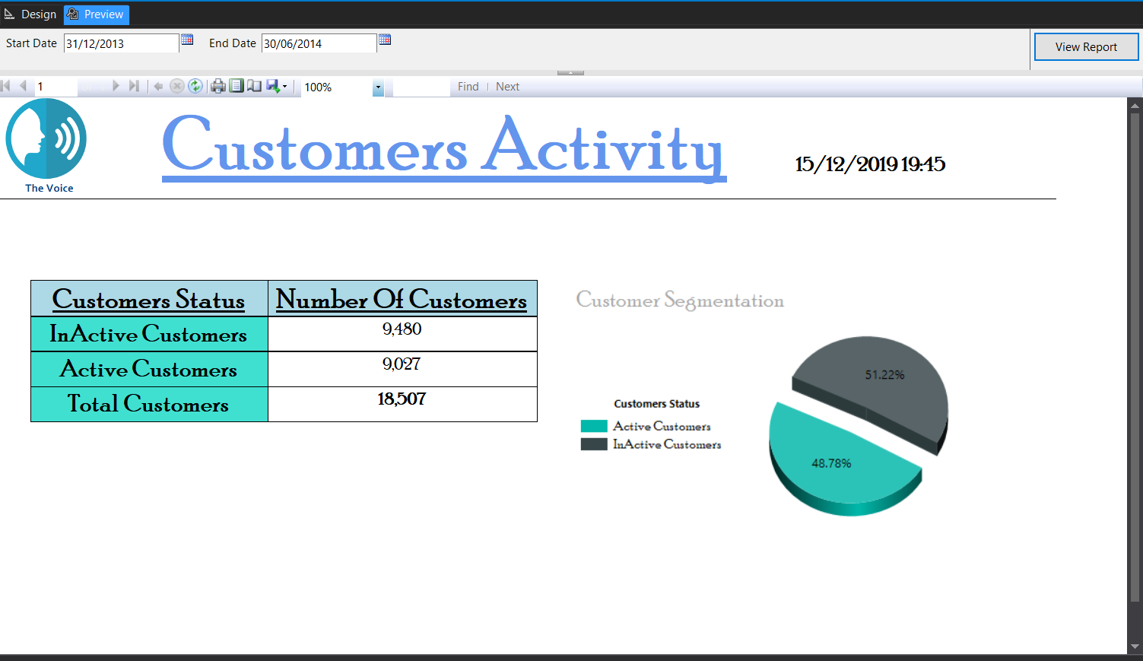The differences between active and inactive customers can be seen.

The second report shows us the number of sources used (Origin Usage (Voice, Massage and Data) by each country, each operator, and how much each customer uses.

You can see that a total of 30,557 uses were made.

In this report we used to toggled on country and operator columns.

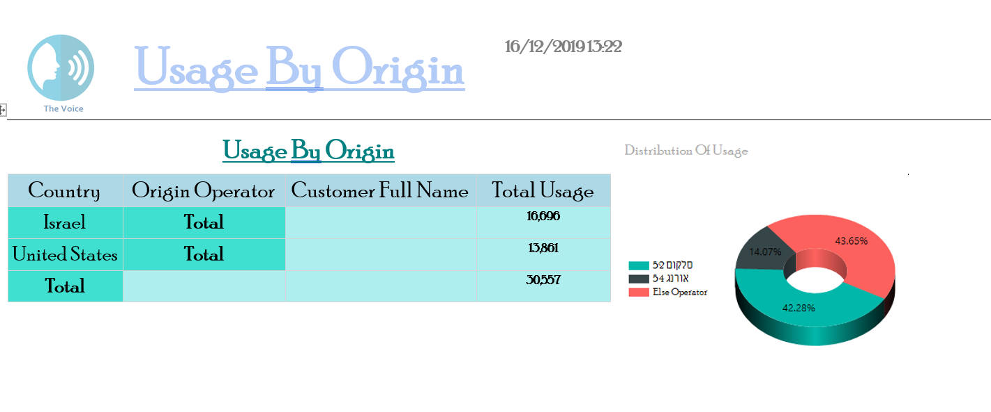In addition, we chose to show the amount of uses by operator with a pie chart.

There are filters by country name and date.

(The image was taken from a "Word" file after exporting to the chart so we can show it all).

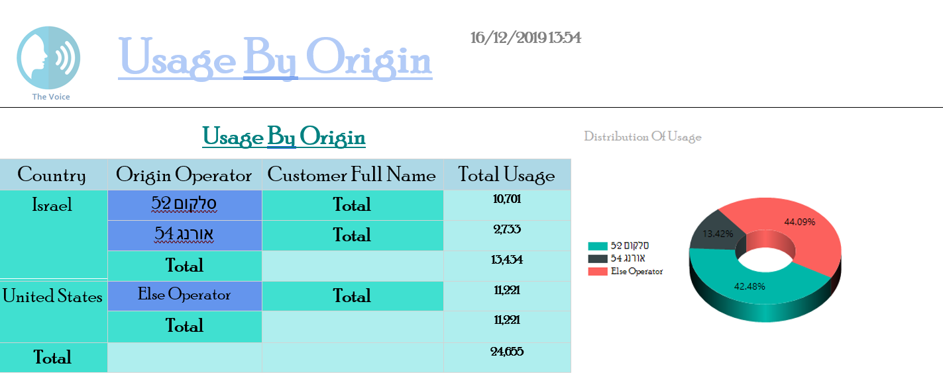

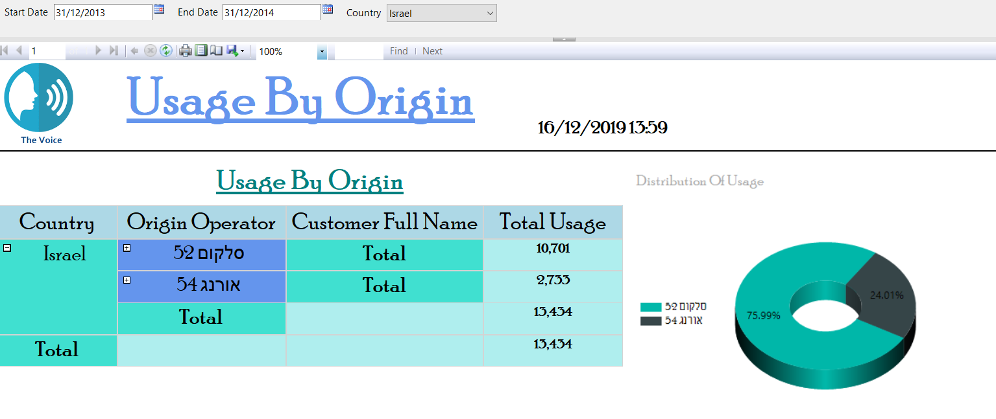

The third report shows the call types, the amount of duration, the amounts of money and the total use of the data type.

In this report, we implemented the drill through. When the mouse is on the call types, you can click it.

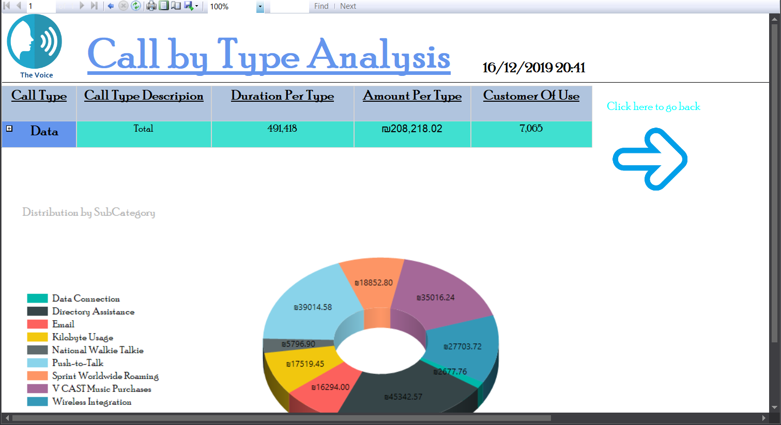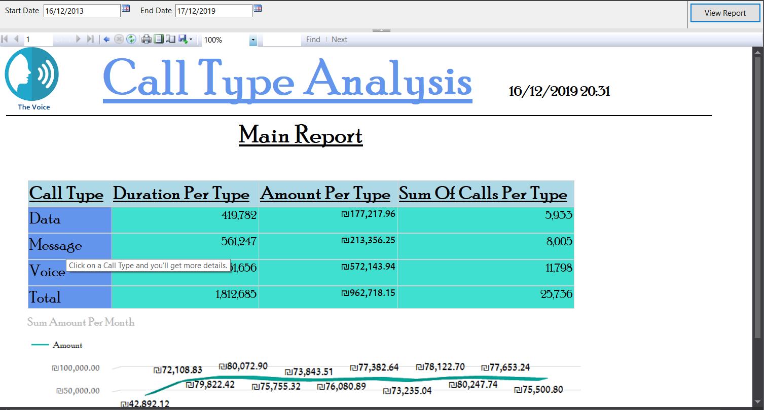In addition, in the report to which you are transferring, nothing can be done except to press the blue button.

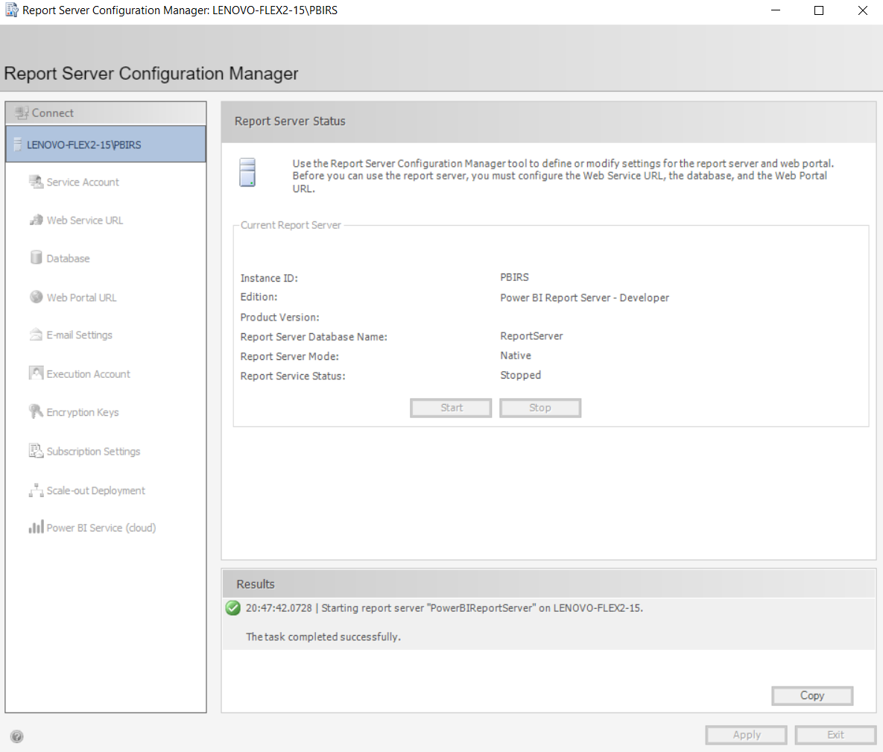After the reports are prepared, a report server must be produced by "Report Server Configuration Manager"

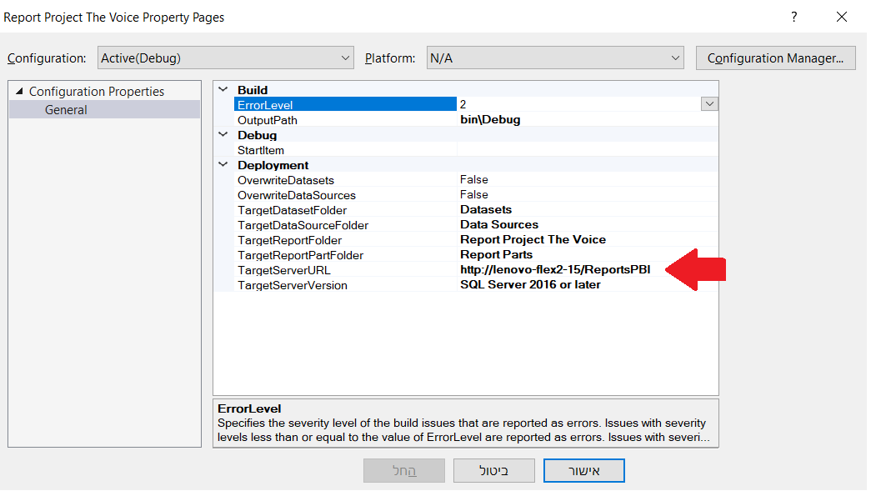Before performing the SSRS deployment process, you must enter assets and set the URL that is actually our Report Server.

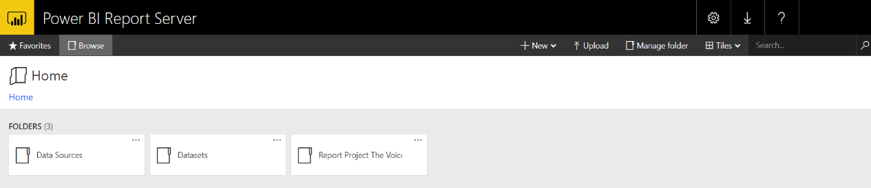Now, we can look at the reports we created in SSRS.